AW133

BLE enable
BBQ Thermometer

Product Profile

1.6 | Display information updated | Orange |  | 19-Dec-13
1.5 | Display information updated | Orange |  | 12-Dec-13
1.4 | Definition update | Orange |  | 3-Dec-13
1.3 | Disconnection action | Orange |  | 12-Nov-13
1.2 | Display information updated | Orange |  | 31-Oct-13
1.1 | Key Flow update/ Alert condition | Orange |  | 23-Oct-13
1.0 | First Release | Orange |  | 21-Oct-13
Rev. | Description | Pmgt | PDD | Date
- Product description

A wireless cooking thermometer with metal probe (AWR129) measures the temperature of the cooking meat. Also, an application can be used on the smart phone to review the cooking information & remote control the cooking thermometer via BLE technology.

Features

- Basic features
  - Dual Probe design
  - Measure meat & air temperature
  - RGB light for cooking progress & backlight
Working Mode:
    - Select meat type & correspondent doneness level for target cooking temperature
    - User adjustable target cooking temperature
    - Count up & Countdown timer
  - Buzzer alert
  - IPX3 Water splash resistant
  - Touch Key
  - Desktop stand
  - Bluetooth low energy technology
App Feature (iOS/Android)
  - Instant temperature
  - Cooking progress
  - Sound & vibration alert
  - Different modes setting
  - Control main unit

- LCD display for main unit
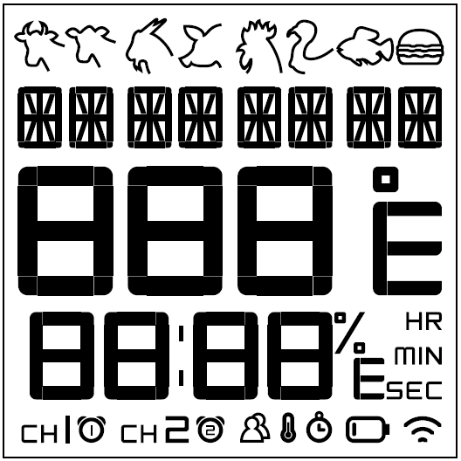
1st Line : Meat indicator :Beef / Veal / Lamb / Hamburger / Pork / Chick / Turkey / Fish
2nd Line : *segment for Cooking Mode(Meat type, Target Temp. Timer) & Doneness level & Meat name & Cooking status
3rd Line : Current temperature
4th Line : Cooking progress in %, Cooking Time, Target Temperature & indicator, Hour/Min indicator
5th Line : Probe 1 / 2 indicator, Alert indicator on Probe 1/2, Low battery indicator, Mode Indicator (Meat / Target / Timer

Other:
  - Memory for all modes
  - Have key Tone
  - Start up will call back last mode & setting.
  - If the program not started, Probe 1/2 indicator flash in 1times per sec
  - Probe 1/2 indicator will stay after program started
  - Auto Turn off after no start operation (3hrs)
  - After remove probe, operation will be stop, press need start again
*Probe 1/2 indicator will always ON/Flash basic on user selection
- If disconnect, follow below points.
1) Unit no battery : Apps pass setting to unit
2) App crash : Unit pass setting & current temp to app
3) App out of range : Unit pass setting & current temp to app

After connection, unit pass information to App, App analysis information
- Follow start side
- If both side is start, follow unit
- If both side is not start, follow the side which have setting
- If both side both have setting but different, Apps pop up question : follow unit setting?
- Alert mode :
Progress: Cooking > Pre-alert > Ready > Over Cook
Display:
  - Probe 1/2 Alert indicator will flash 2 times in 1 sec when it is “Pre-alert”
  - Probe 1/2 Alert indicator will stay when it is “Ready”
RGB light changing:
  - RGB lighting will keep change basic on cooking progress:
    - Yellow(Cooking)
    - Amber(Pre-alert)
    - Red(Ready)
    - Red in flash(Over cook)
  - For normal mode, the backlight will be yellow
Beeping:
  - (Pre-alert) 1 beeps in 1 sec, repeat 4 times only
(Activates only when temperature is rising at the pre-alert temperature. i.e. No response at the pre-alert temperature when temperature is falling)
  - (Ready)4 beeps in 0.5 sec, next 0.5 will no beeping. Repeat in whole time.(Activates only when temperature is rising at the alert temperature. i.e. No response at the alert temperature when temperature is falling)
  - (Overcook) 4 beeps in 1 sec in whole period and so on until any key is pressed (Long Beep)
(Activates when it is equal to or above the overcook temperature)
Pop up Alert:
  - If one alert trigger, change the display information to alerted one (start from Pre-alert)
*User are able to press [-/+] to change to other probe
  - Pop up Alert Priority : Over Cook > Ready > Pre-alert
  - For the secondary alert will only show on the indicator only
  - Once the first alert stop, secondary alert will be active (Beep & RGB) and pop up

- Three cooking mode
Cooking mode A : Meat type mode (Profile Mode-UM)
- User to select type of meat and doneness level
LCD display :
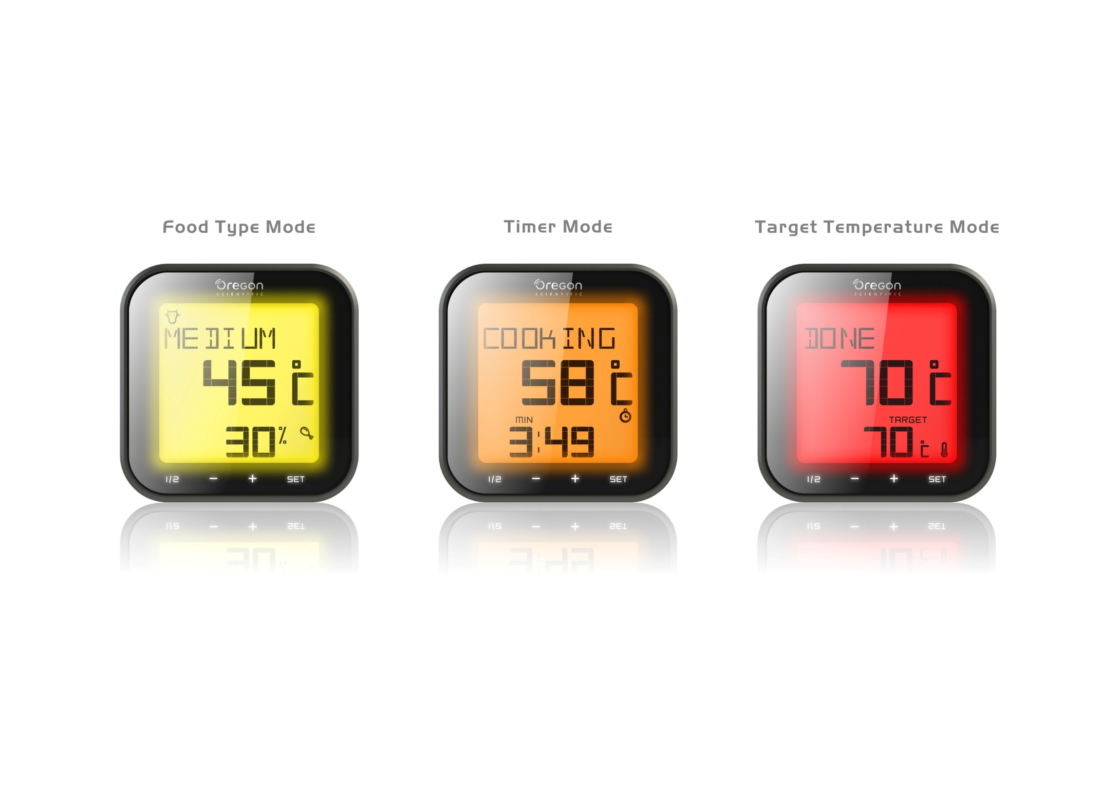
Progress in %
Current Temperature
Doneness Level / Display meat name (setting mode)* In App Customize mode(Display C), Animal icon flash
Program | Not Start | Start
Meat Icon | ON | ON
Doneness | ON | ON, toggle with cooking status
Current Temperature | ON | ON
Progress in % | Display --% | ON

Cooking, Pre-alert, Alert and Overcook-alert temperature table

 | Alert type | LED Backlight | Current temp digits | Beef / Lamb/ Veal | Hamburger | Pork | Turkey / Chicken | Fish
Cooking: Rare | Light | Yellow | Stay on | <130°F | N/A | N/A | N/A | N/A
Cooking: Medium Rare | Light | Yellow | Stay on | <140°F | N/A | <140°F | N/A | N/A
Cooking: Medium | Light | Yellow | Stay on | <155°F | N/A | <155°F | N/A | N/A
Cooking: Well Done | Light | Yellow | Stay on | <165°F | <155°F | <165ºF | <175°F | <140°F
Pre-alert: Rare | Light /Beep(per 1sec) | Amber | Stay on | 130 - 134°F | N/A | N/A | N/A | N/A
Pre-alert: Medium Rare | Light /Beep(per 1sec) | Amber | Stay on | 140 - 144°F | N/A | 140 - 144°F | N/A | N/A
Pre-alert: Medium | Light /Beep(per 1sec) | Amber | Stay on | 155 - 159°F | N/A | 155 - 159°F | N/A | N/A
Pre-alert: Well Done | Light /Beep(per 1sec) | Amber | Stay on | 165 - 169°F | 155 - 159°F | 165 - 169ºF | 175 - 179°F | 140 - 144°F
Alert: Rare | Light /Beep(per 0.5sec) | Red | Stay on | 135 - 145°F | N/A | N/A | N/A | N/A
Alert: Medium Rare | Light /Beep(per 0.5sec) | Red | Stay on | 145 - 160°F | N/A | 145 - 160°F | N/A | N/A
Alert: Medium | Light /Beep(per 0.5sec) | Red | Stay on | 160 - 170°F | N/A | 160 - 170°F | N/A | N/A
Alert: Well Done | Light /Beep(per 0.5sec) | Red | Stay on | 170 - 179°F | 160 - 169°F | 170 - 179ºF | 180 - 189°F | 145 - 154°F
Over Cook : Rare | Light / Beep(per 0.25sec) | Red in Flashes (on: 0.25 sec  off: 0.25 sec) | Stay on | > 145°F | N/A | N/A | N/A | N/A
Over Cook : Medium Rare | Light / Beep(per 0.25sec) | Red in Flashes (on: 0.25 sec  off: 0.25 sec) | Stay on | > 160°F | N/A | > 160°F | N/A | N/A
Over Cook : Medium | Light / Beep(per 0.25sec) | Red in Flashes (on: 0.25 sec  off: 0.25 sec) | Stay on | > 170°F | N/A | > 170°F | N/A | N/A
Over Cook : Well Done | Light / Beep(per 0.25sec) | Red in Flashes (on: 0.25 sec  off: 0.25 sec) | Stay on | > 179°F | > 169°F | > 179ºF | > 189°F | > 154°F
- Progress in %
Base on current temperature / Doneness temperature:
Rare: X/135°F
Medium : X/145°F
Medium Well: X/160°F
Etc….

Customer adjust temperature on Smartphone
- Customer can be adjust doneness level on app.
- Every time turn on the app, will send the doneness temperature to main unit.
- Main unit will have

Cooking mode B : Target Temperature mode
- User to set target cooking temperature manually
LCD display :
Current Temperature
Status
Target Temperature/Progress % (Toggle)
Program | Not Start | Start
Meat Icon | OFF | OFF
Status | Display -------- | ON
Current Temperature | ON | ON
Target Temperature | ON | ON, toggle with Progress %

- If current temperature is 5°F < target temperature, display “COOKING”, backlight as Yellow
- e.g. Target 100F, 0-95F
- If current temperature is target temperature-5°F, display “ALMOST”, backlight as Amber, (Pre-alert) 95-100F
- If current temperature = target temperature +10°F, display “DONE” , backlight as Red, (Alert)
- 100F-110F
- If current temperature is 10°F > target temperature, display “OVERCOOK” , backlight as Red in flash
- >110F

Cooking mode C: Timer mode
- Individual count up or countdown timer
LCD display:
Counter Up/Down Timer
Current Temperature
State
Program | Not Start | Start
Meat Icon | OFF | OFF
Cooking status | Display -------- | ON
Current Temperature | ON | ON
Timer | ON | ON

- 4-digit display: HH:MM or MM:SS (toggle display)
- Max count up / count down: 23 hours 59 minutes (59 seconds)
- If countdown time > 3min, display “COOKING”, backlight as Yellow
- If countdown time = 3-0min, display “ALMOST”, backlight as Amber
- If count up time = 0-3min, display “DONE” , backlight as Red
- If count up time over 3min , display “OVERCOOK” , backlight as Red in flash

- Temperature Measurement

Probe’s max measuring temperature | : | 716°F (380°C)
Temperature measuring range | : | 32°F - 572°F (0°C - 300°C)
Target and Current temperature display range | : | Flash 32°F (actual temp < 32°F)  Display 32°F - 572°F (actual temp = 32°F - 572°F)  Flash 572°F (actual temp > 572°F)  Flash 0°C (actual temp < 0°C)  Display 0°C - 300°C (actual temp = 0°C - 300°C)  Flash 300°F (actual temp > 300°C)
Temperature display format | : | User selectable °F/°C (default °F)
Temperature resolution / accuracy | : | +/-2ºF (50ºF to 212ºF)  +/-4ºF (212ºF to 302ºF)  +/-6ºF (302ºF to 392ºF)  > 6ºF (392ºF to 572ºF)  +/-1ºC (10ºC to 100ºC)  +/-2ºC (100ºC to 150ºC)  +/-3ºC (150ºC to 200ºC)  > 3ºC (200ºC to 300ºC)
Heat resistance for transmitter / table stand  Measurement cycle : 6 sec per times  Default setting  *When no history setting, display ----  **When no history setting, display ----  *When no history setting, display ---- | : | around 140°F (60 °C)
  Meat type Setting | Target
  - Meat | Beef
  - Doneness | Medium
  Target Temp Setting | Target
  - Start temperature | 145F
  Timer Setting | Target
  - Start Time | 00:00:00
KEY ASSIGNMENT
 | Target
Button | Location
Set | Front
Start/Stop | Front
+ | Front
- | Front
°C / °F | Inside Battery Compartment
reset | Inside Battery Compartment
Lighting | Inside Battery Compartment

C. Key Operation
Touch Key
[Set]
- Press to enable mode selection & Setting
- Press to confirm
- Press & Hold 2 sec to Turn ON & OFF
[Start/Stop]
- Press to start / stop program
- Press & Hold to remove record setting (5sec)
*Only able in no program start
[+/-]
- Press to change mode, Meat > Target temperature> Timer & increase/decrease value in setting mode
- Press to change Probe1/2 setting
*Always display Probe 1 / 2 indicators
*When the program is running, able press +/- to change probe

[+] & [-]
- Enable BLE pair up 30sec
*Flash in pair up / Stay in connected

Meat Type Mode
[Set]
- After mode selection, set Meat type > Doneness Level, press again to confirm
*Only enable when operation is stop
[Start/Stop]
- Press to start / stop operation
[+/-]
- Press to increase/decrease value in setting mode
Target Temp Mode
[Set]
- After mode selection, set target temperature, Press again to confirm
*Only enable when operation is stop
[Start/Stop]
- Press to start / stop operation
[+/-]
- Press to increase/decrease value in setting mode
*Single Press to change in 1
*Press & Hold for 2 sec to change in 10
Timer Mode
[Set]
- After mode selection, set Time HH&MM/ MM&SS > HH > MM > SS Press again to confirm
*Only enable when operation is stop
[Start/Stop]
- Press to start / stop operation
[+/-]
- Press to increase/decrease value in setting mode
*Single Press to change in 1
*Press & Hold for 2 sec to change in 10

Battery Cover
[°C/°F] Slide switch
- Slide to select °C or °F unit (Default setting: °F)
[Reset] button
- Power reset the unit
[Light] switch
- Slide to ON/OFF RGB lighting, backlight

Others
- Press any key to activate LED(Yellow) backlight for 5 seconds (Not Start), Follow cooking status if start

- Demo sequence and key operation

Hold [Set] and then press & hold [Start/Stop] key to turn on the unit and enter demo mode.
2. Starts demo sequence once
3. If no key is pressed for 5 minutes after the demo is finished, the unit will go to sleep mode.
4. Any key pressed during the 5 minutes will start the demo sequence once.
- In sleep mode, any key pressed to wake up the unit and start the demo sequence once.
- Hold [Meat] and then press & hold [On/Off] key to exit the demo mode and turn off the unit

Demo sequence

 | Meat Type | Doneness | Target Temp | Current Temp | RF icon | Display period | Alert
1st display (Default display after demo is finished. Stays on for 5 minutes before sleep) | Beef | Rare | 135°F | 77°F | On | 2 sec
2nd display | Beef | Medium | 145°F | 77°F | On | 2 sec
3rd display | Beef | MediumWell | 160°F | 77°F | On | 2 sec
4th display | Beef | Well done | 170°F | 77°F | On | 2 sec
5th display | Beef | Well done | 170°F | 128°F | On | 4 sec
6th display | Beef | Well done | 170°F | 138°F | On | 4 sec
7th display | Beef | Well done | 170°F | 160°F | On | 4 sec
8th display | Beef | Well done | 170°F | 165°F | On | 6 sec
9th display | Beef | Well done | 170°F | 170°F | On | 6 sec

Power

Main unit (Receiver):
- Uses 3 pieces of 1.5V UM-3 or “AA” size batteries (included)
- Battery life: approx. 100 hrs using alkaline battery

Standard Requirement

Regulation: CE & FCC approval
Water resistance: IPX3

Accessories

- Reference rendering

